Surds

Square roots arise naturally in both trigonometry and co-ordinate geometry.  These expressions all have the same value : 0.23958 corrected to 5 decimal places. Calculate some of them and think about how one is changed into another.
  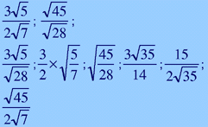

A surd is a square root which cannot be evaluated without approximation.
is not a surd, notice
= 5 which is exact.
is a surd, notice
= 3.6 is only an approximation.
Any expression which involves surds can be written in many forms.
In this lesson we will look at different forms of surds and develop methods for simplifying them.

Simplification

It is usual to write a surd in its simplest form. Here are some guidelines to help you decide if a surd is in its simplest form:  - the numbers inside square roots should be prime numbers,  - terms that are alike should be collected together,  - fractions should have no surds in the denominator.
  = 4 × 10
  = 40

Square roots

The square root of a product is the product of the square roots.  Also, the square root of a quotient is the quotient of the square roots.  These changes can help to produce the simplest form of a surd.
  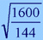 | 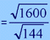
   | 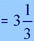

Rationalisation
When there is a surd in the denominator it should be changed to an integer. This technique is called rationalisation.
  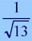

To rationalise: multiply the expression by another fraction that is equal to 1.  This should be selected to change the denominator into a whole number.
  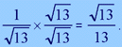

Rationalising is also used to simplify more complex surds.
  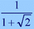

The new fraction is chosen so that the denominator takes the form (a + b)(a - b) which can be expanded to the form (a² - b²).
  The fraction chosen is 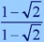

(a² - b²) will always be a whole number because a, b or both will have square roots
  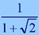× 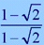

This gives the simplest form of the surd.
  