Working with
Tree Diagrams

Answer the following questions pertaining to
tree diagrams.
1.
 | The 4 aces are removed from a deck of cards. A coin is tossed and one of the aces is chosen. What is the probability of getting heads on the coin and the ace of hearts? Draw a tree diagram to illustrate the sample space.
  2.You are at a carnival. One of the carnival games asks you to pick a door and then pick a curtain behind the door. There are 3 doors and 4 curtains behind each door. How many choices are possible for the player?

3. | There are 3 trails leading to Camp A from your starting position. There are 3 trails from Camp A to Camp B. How many different routes are there from the starting position to Camp B? Draw a tree diagram to illustrate your answer. | 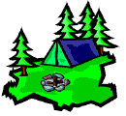

4. | A spinner has 4 equally likely regions numbered 1 to 4. The arrow is spun twice. What is the probability that the spinner will land on a 1 on the first spin and on a red region on the second spin? Draw a tree diagram to represent your answer.  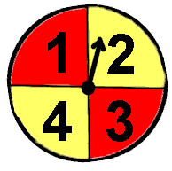 | Choose:

5. | There are two identical bottles. One bottle contains 2 green balls and 1 red ball. The other contains 2 red balls. A bottle is selected at random and a single ball is drawn. What is the probability that the ball is red?

