Tree Diagrams - Solutions |  | MathsDirect

Question 1
Which result is more likely?
a) Getting 2 girls, when randomly picking 2 people from a group of 5 boys and 5 girls
b) Getting 4 girls, when randomly picking 4 people from a group of 10 boys and 10 girls.

To answer this, there is no need to actually draw out a tree diagram as we are only interested in the result of one branch.
a)
In the first situation, we only need to multiply the probability of getting a girl with the first pick, by the probability of getting a girl when both the number of girls and the total number are reduced by 1.
For the first pick, you have 5 girls out of a total of 10. | 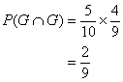 | For the second pick, you now have 4 girls out of a total of 9.

b)
The same method is used in the second situation, but you must continue for 2 more steps, remembering that each time both the number of girls and the total number have to go down by 1.
 | 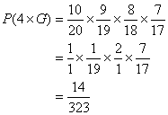 | Cancel terms first, to make the calculation easier [(10/20)(9/18)(8/2,2)].

To find which fraction is larger, there are 3 methods:
1 Use a calculator - Not Good!!
2 Write the fractions with the same denominator - awkward, as you will need a very large denominator.
3 Write the fractions with the same numerator (the smaller the denominator the larger the fraction).
Using the third method | 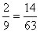

It is now easy to say that | 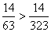
Therefore situation a) is more likely.

Question 2
A purse contains 4 £2 tokens and 6 £3 tokens. Three tokens are drawn at random from the purse.
Find the probability that the tokens will add up to:
a) | £6
b) | more than £7
What value of tokens would you expect to pick in total?

For this question we will need to draw a tree diagram.
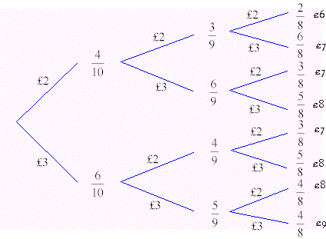 | To find the probability of any particular result, just multiply along the branches.

a)
The only way of picking out £6 by going along the top branches.
Therefore | 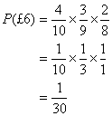 | To make the multiplication easier, cancel terms down first.
 | 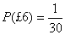

For the second two parts of the question, we will need to know the probabilities along all branches of the tree. We may as well put these in a table
£6
£7
£7
£8
£7
£8
£8
£9

So collecting together the results, we get
£6
£7
£8 | 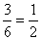
£9

We can check that we have not made a mistake. The fractions above should add up to 1.
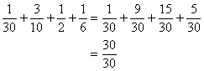

We can now answer the final two parts of the question.
b)
For this, we just need to add the probabilities of getting £8 and £9. | 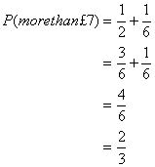 | Write with a common denominator.  Simplify.
Therefore | 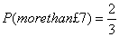

To find the expected total we need to do the sum of each possible total, multiplied by its probability.
 | 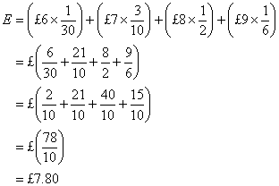 | To avoid using a calculator, write each fraction over 10.

Therefore

