More Examples of Combined Probability
What is the probability that three students re-taking GCSE mathematics picked at random, will all gain a grade C or above?
Student probability
If two students are picked at random, what is the probability that one or the other (or both) gets a grade C or above?
You can look at this probability with a tree diagram.
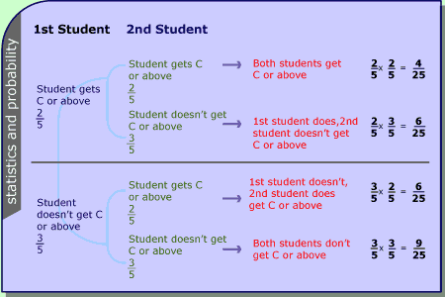
The blue text shows what happens to the first student picked at random; below the description is the probability of that event happening.
The green text shows what happens to the second student picked at random; below the description is the probability of that event happening.
The red text shows the combined events (what happens to both students); to the right is the probability of each combined event happening (obtained by multiplying the two separate probabilities together).
The total of all the probabilities on the right is 1 as all the possible outcomes are represented.
The probability of either one or both students getting a grade C or above is the sum of the first three combined probabilities (all except the probability of both students not getting a grade C or above) i.e.
 | + |  | + |  | =
Notice that you multiply probabilities to find the probability of something and something else happening and you add probabilities to find the probability of something or something else happening.

