Back to Print Offs menu
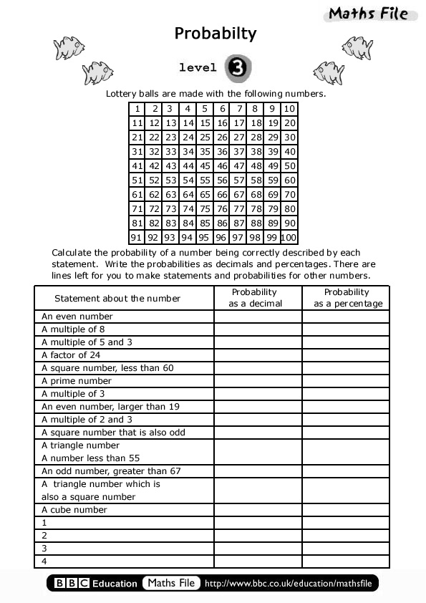
Back to Print Offs menu

