Unit 2 Section 1 : Place Value
In this section we will look at how we round numbers to a given accuracy.
We need to remind ourselves about the idea of place value in any particular number.
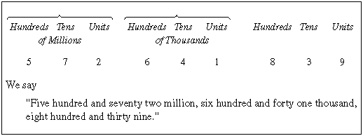
The "4" in the number above is actually worth 40000, because the place value of its position is ten-thousand (10000).

Example Question 1
Work out the value of the "6" in each of the numbers below.
(a) 167
(b) 2006
(c) 6423

Rounding
There are times in Mathematics where we don't want to give all the detail of a number, so we round it to a given accuracy.
Think about the number 7451. We want to write this number to the "nearest ten".
The two "nearest tens" to 7451 are 7450 (below) and 7460 (above). The diagram below shows this:
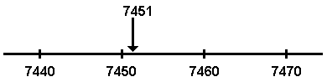
We can easily see now that 7450 is the "nearest ten", so 7451 to the nearest 10 is 7450.
Now we want to write 7451 to the "nearest hundred".
Look at this diagram which shows the "nearest hundreds" to 7451:
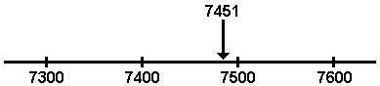
We can see that 7451 to the nearest 100 is 7500.
Finally, we want to write 7451 to the "nearest thousand".
The "nearest thousands" to 7451 are 7000 and 8000, as shown below:
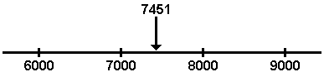
We can see that 7451 to the nearest 1000 is 7000.

Note
If a number is exactly halfway between two "nearest values", we always round up to the higher value.
For example, imagine rounding 350 to the nearest 100.
The diagram shows that 350 is exactly halfway between 300 and 400:
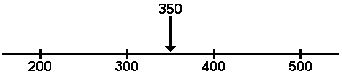
The "5" always rounds up, so 350 to the nearest 100 is 400.

Example Question 2
Work out the answers to the questions below.
(a) What is 2716 to the nearest 10?
(b) What is 2716 to the nearest 100?
(c) What is 2716 to the nearest 1000?
Exercises
Work out the answers to the questions below and fill in the boxes.

Top of Form
Question 1
Write each of these numbers to the nearest 10.

(a) 89
(b) 45
(c) 72
(d) 12
(e) 9
(f) 2
(g) 4713
(h) 5629
(i) 4755

Bottom of Form
Top of Form
Question 2
Write each of these numbers to the nearest 100.

(a) 376
(b) 1417
(c) 24699
(d) 101
(e) 149
(f) 251

Bottom of Form
Top of Form
Question 3
Write each of these numbers to the nearest 1000.

(a) 1001
(b) 2500
(c) 3999
(d) 132400
(e) 56471
(f) 555511

Bottom of Form
Top of Form
Question 4
A milkman delivered 109865 bottles of milk in one year.
Write the number of bottles to:

(a) the nearest 100
(b) the nearest 1000
(c) the nearest 10
(d) the nearest 10000

Bottom of Form
Top of Form
Question 5
A school has 1256 pupils. Write this number to:
Write this number to:

(a) the nearest 10
(b) the nearest 100
(c) the nearest 1000

Bottom of Form
Top of Form
Question 6
Work out the value of the "9" digit in each of these numbers.

(a) 19
(b) 91
(c) 190
(d) 1971
(e) 19800
(f) 2190
(g) 9100001
(h) 1001911
(i) 900371423

Bottom of Form
Top of Form
Question 7
Place the numbers below in order, with the smallest first. Separate your answers with commas, like this :
(a) 147, 222, 316, 47, 32, 1004
(b) 1472, 3416, 621, 3813, 1471, 15721
(c) 6000, 60000, 3000, 30000, 4000000
Bottom of Form
Top of Form
Question 8
You are going to make a 5-digit number from the digits 4, 6, 3, 2 and 8. Each digit can only be used once.
(a) What is the largest number you can make?
(b) What is the smallest number you can make?
Bottom of Form
Top of Form
Question 9
You are given the number 1735. You are allowed to swap the positions of any two digits.
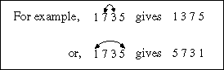
(a) What is the largest number you can make with one swap?
(b) What is the smallest number you can make with one swap?
Bottom of Form
Top of Form
Question 10
A newspaper report states that 42000 people watched a football match.
The actual number has been rounded to the nearest 1000.
(a) What is the largest number of people that could have watched the match?
(b) What is the smallest number of people that could have watched the match?
Bottom of Form
Top of Form
Question 11
The table below shows the results and attendances for some football matches.
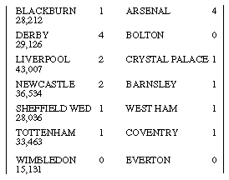 | (a) Which match had the largest attendance?  (b) What is the total attendance of all the matches to the nearest 1000?  (c) How many more people watched Newcastle than watched Wimbledon, to the nearest 100?
Bottom of Form

Bottom of Form

