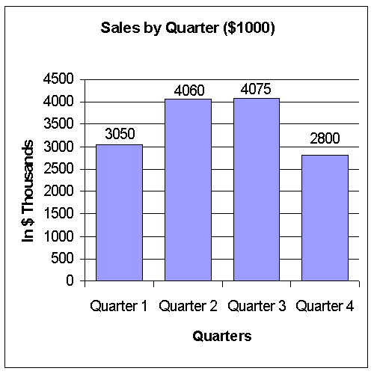

- Which was the second best quarter?
- What were the lowest quarterly sales?
- In what quarter did we have the worst sales?
- Did our sales for the year reach our budgeted goal of $14 million?
- In what months did we have our best sales?

Use this graph to answer the next five questions:
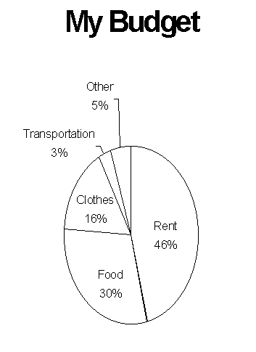
- What percent of my budget is spent on clothes?
- If my monthly income is $600, how much do I spend on food?
- What two expenditures, added together, equal what is spent on rent?
- If I go to the movies on the last Tuesday of each month, under what heading would this expense be placed?
- What is my single, largest expense?

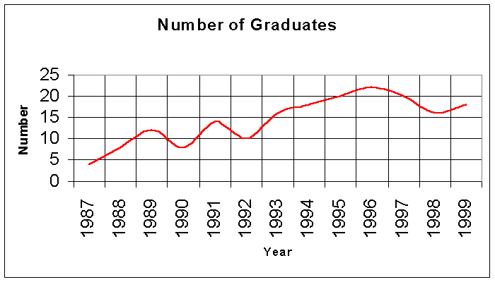
Use this graph to answer the next five questions:

- How many students graduated in 1992?
- In what year did we have the greatest number of graduates?
- What is the fewest number of graduates we have had?
- Were there more graduates in 1989 or in 1998?
- Taking the whole graph as a basis, will we likely have more or less graduates in 2000 than we had in 1999?

Use this graph to answer the next five questions:
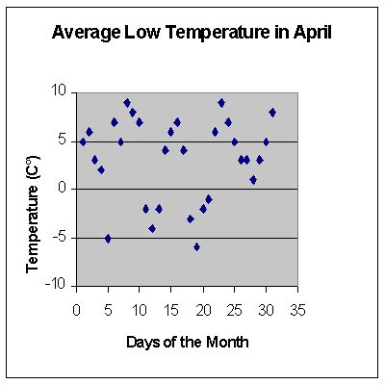
- What was the lowest temperature for the month?
- On what day(s) did we have the highest temperature recorded?
- Estimate the average temperature for the month.
- On how many days was the recorded temperature between 3 and 7°C?
- What was the recorded temperature on April 26th?

