Decision Making
Karen and her family have just moved into a new neighborhood. Karen wants to earn money by baby-sitting for families with young children. She asked other students her age how much they charged for baby-sitting. The results are listed in the chart below.
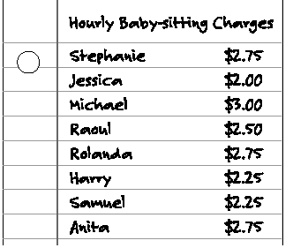

1. Suppose Karen wants to be the least expensive baby-sitter in the neighbourhood.
How much should she charge?

2. Suppose Karen wants to charge the same hourly rate as most of the other baby-sitters. How much should she charge? Explain.

3. Suppose Karen wants her hourly rate to be higher than the rate of half of other baby-sitters, but lower than the hourly rate of the rest of the baby-sitters. How much should she charge? Explain.

4. In addition to the baby-sitting rates charged by others, what might Karen consider when she sets her rates?

