 | 

Where taxpayers' money is spent
Total public spending is expected to be around £420 billion this year, around £7,000 for every man,
woman and child in the UK. It is set to rise to £455 billion in 2003-04 and to £482 billion in 2004-05.
Chart: Where taxpayers' money is spent
Total managed expenditure in 2002-03 - £420 billion
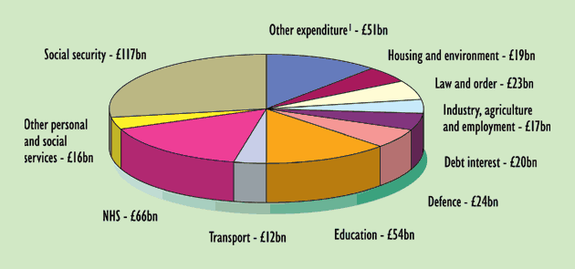

Chart: Where taxes come from

Total receipts in 2002-03 - £400 billion
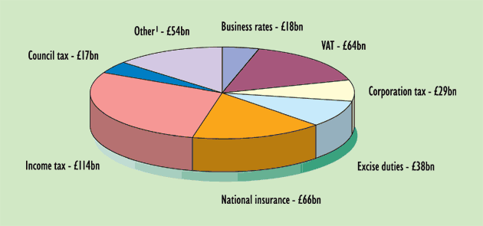

- How many people are these graphs estimating in the UK?

- How much is the public putting into the Health Service?

- How much is it getting out?

