Patterns in Data
The scatter plots show some data representing how many hours some students spend watching television and how many hours they spend doing homework. Their math scores are also recorded. Use the information in the scatter plots to answer the following questions.

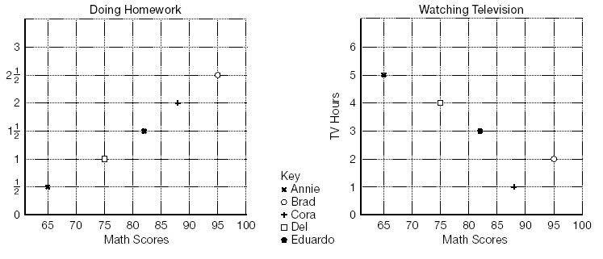

1. Do you see any relationship (trend) between hours spent watching television and math scores?

2. What is the relationship between hours spent doing homework and math scores?

3. Which activity seems to affect math scores the most?

4. If you wanted to tell Annie how to improve her math scores, what advice would you give her?

