PICTOGRAMS

A Pictogram is information shown in picture form.

This is a pictogram showing how many new houses were built in a certain city.

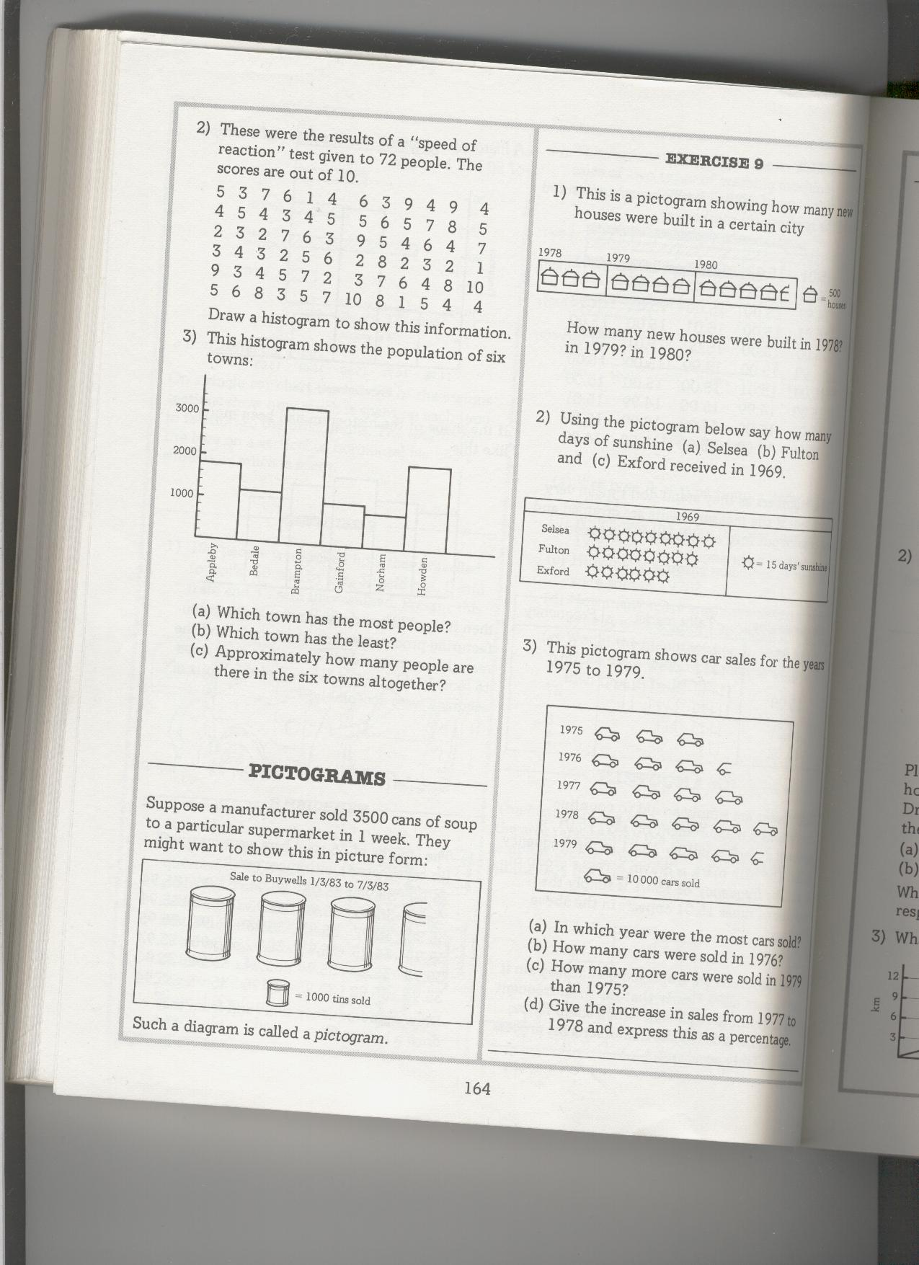

1 house = 500 houses

How many new houses were built in 1978?

How many new houses were built in 1979?

How many new houses were built in 1980?

Using the pictogram below say how many days of sunshine the following places had in 1969:
1 sun = 15 days

- Selsea

- Fulton

- Exford

This pictogram shows car sales for the years 1975 to 1979.

1 car = 10,000 cars sold

- In which year were the most cars sold?

- How many cars were sold in 1976?

- How many more cars were sold in 1979 than in 1975?

- What is the increase in sales from 1977 to 1978?

