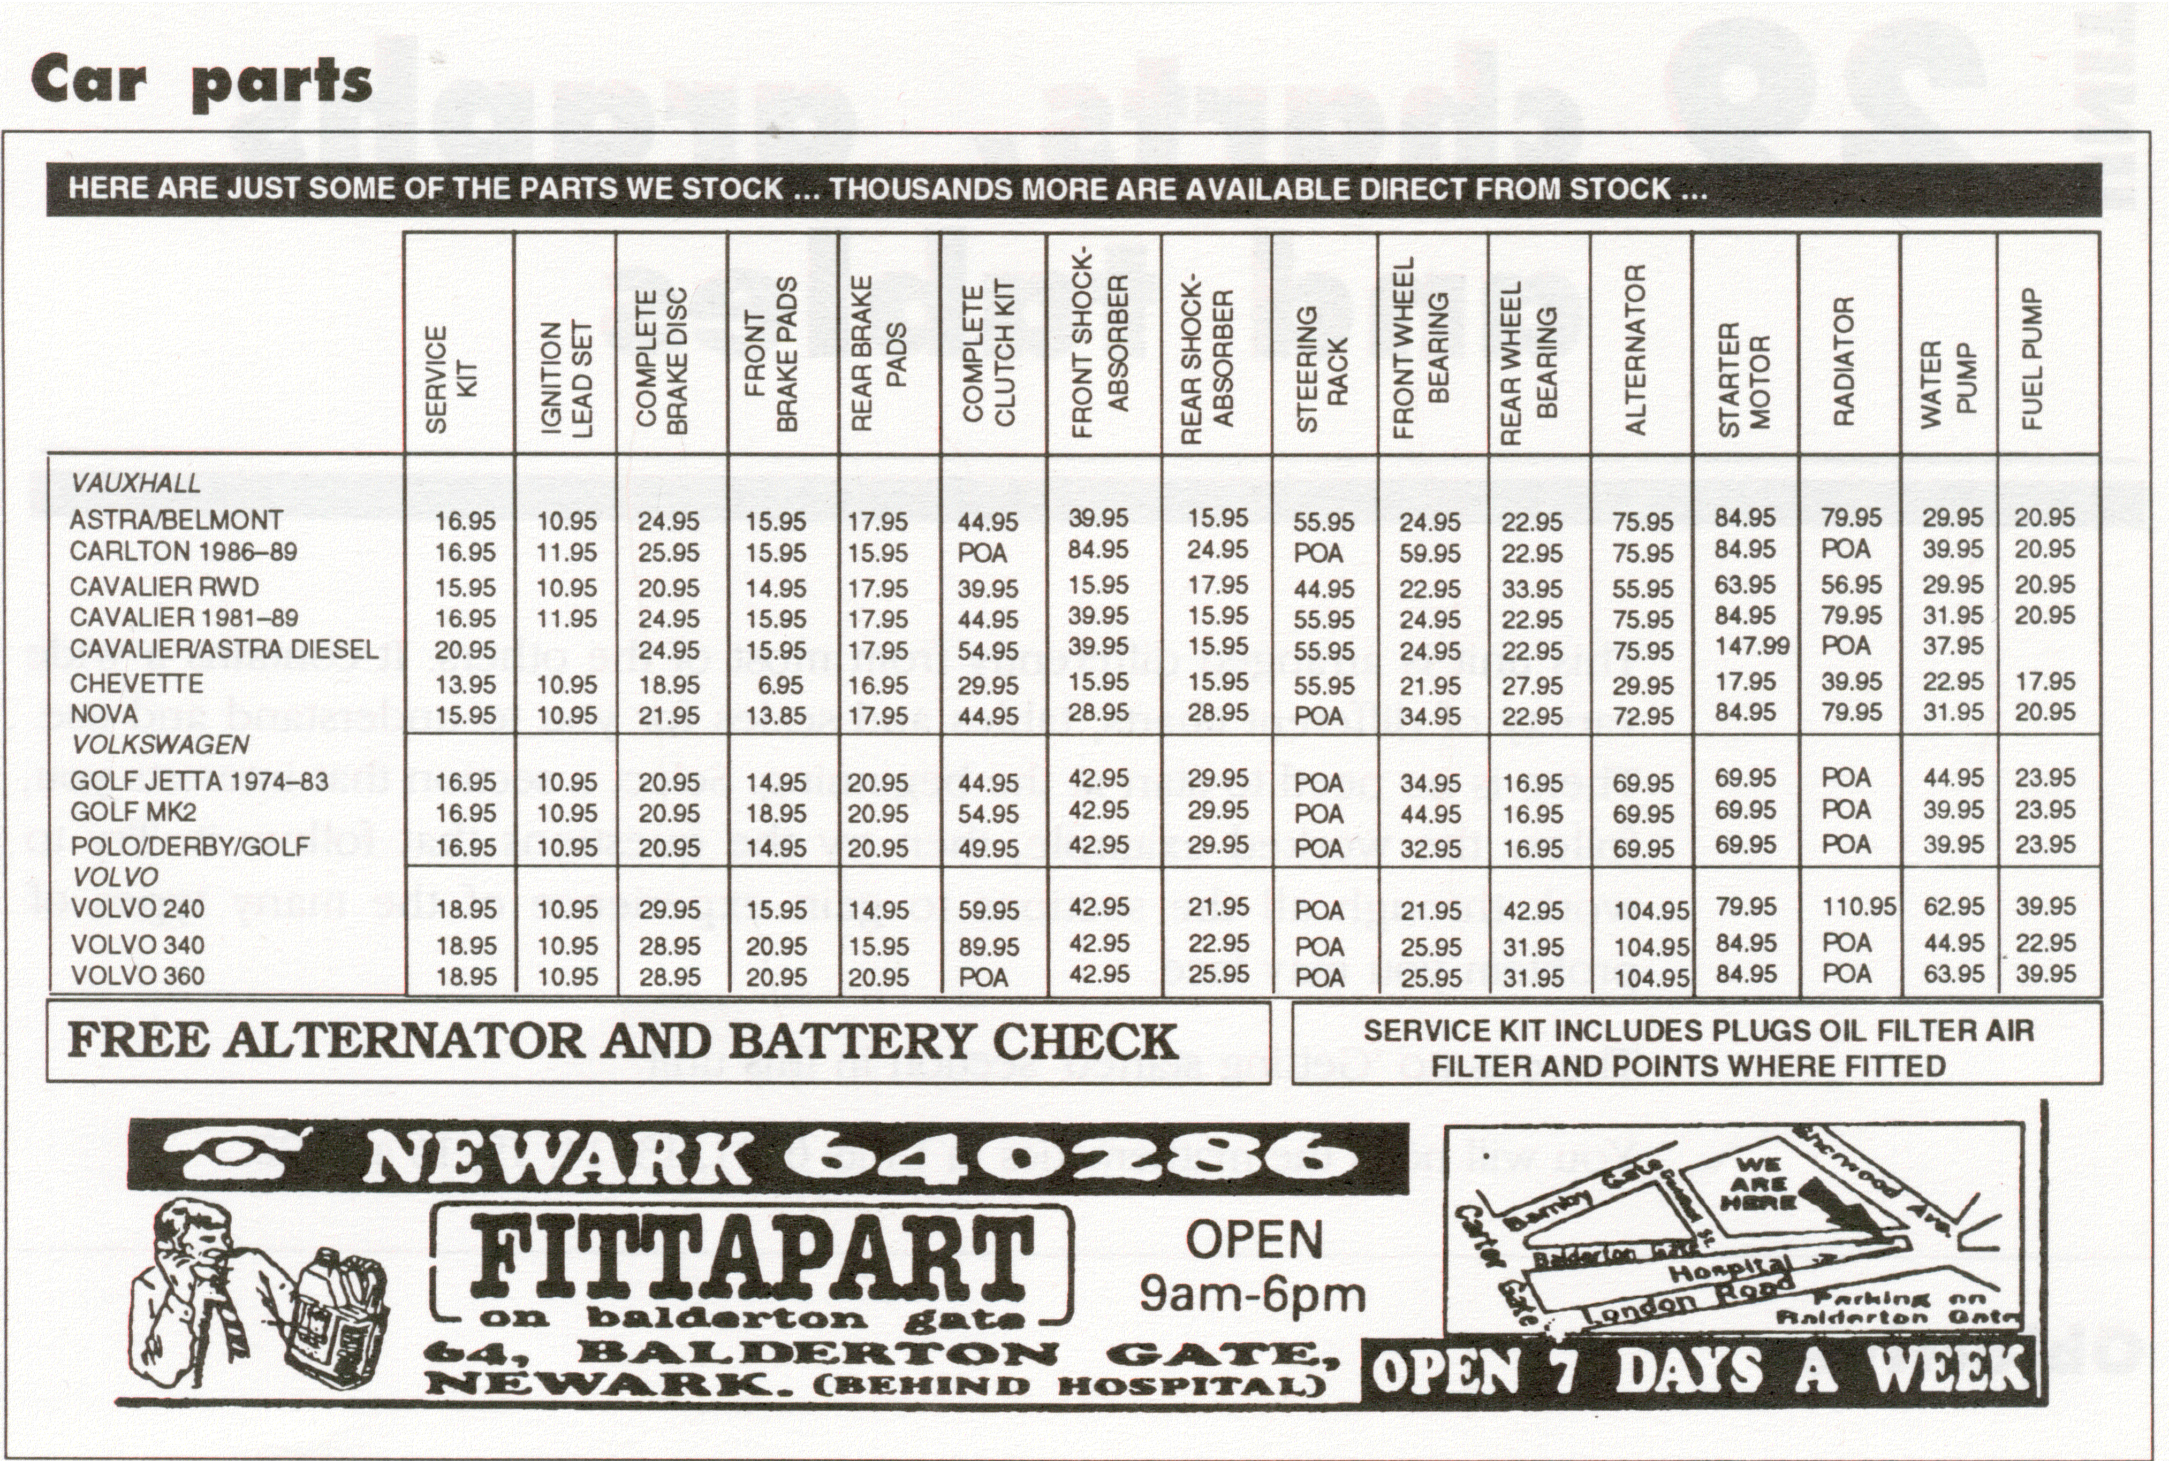
QUESTIONS

- How much does a rear wheel bearing for a Golf MK2 cost?

- How much does an alternator for a Nova cost?

- How much does a service kit and ignition lead set for a Polo cost?

- Find the total cost for a complete brake disc, a front wheel bearing and a water pump for:

  - a Chevette
  - a Golf MK2
  - a Volvo 340

- How much more does a complete clutch kit cost for a Volvo 340 compared with an Astra?

- What does the service kit include?

7. When are the stockists of all these car parts open?

