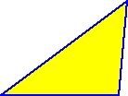
The sum of the measures of the interior angles of a triangle is 180 degrees.
Since all the sides of equilateral triangles are the same length, all the angles are the same...
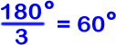
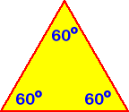
The interior angles of an equilateral triangle are all 60 degrees.
What about a square?
That's easy! By definition, all the interior angles of a square are right angles -- That means that they are all 90 degrees.

What about other regular polygons?
To figure out the measure of the interior angles of a regular pentagon, hexagon, heptagon, etc, we need more than just a protractor! What if we needed to find the interior angle of a regular polygon with 100 sides? That might be a little difficult to draw!

Here are two methods to find the measure of the interior angles of a regular polygon:
For both methods, we will use the fact that the sum of the measures of the interior angles of a triangle is 180 degrees!
METHOD 1:
Let's divide some regular polygons into triangles by connecting one vertex to all of the others...
 |  |  |  | 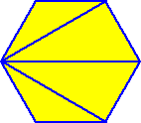
A square has 4 sides and we made 2 triangles. |  | A pentagon has 5 sides and we made 3 triangles. |  | A hexagon has 6 sides and we made 4 triangles.
Do you see the pattern?
A heptagon has 7 sides... so we'd be able to make 5 triangles.
If we had polygon with n sides... we'd be able to make (n - 2) triangles.
Let's start with the square... We made 2 triangles. Notice that all of the interior angles of the 2 triangles make up the interior angles of the square.
The sum of the 2 triangle's angles is
There are 4 equal angles in a square,
so 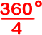gives us that one angle of a square is !
Just what we expected.
Now for the pentagon.
We made 3 triangles.
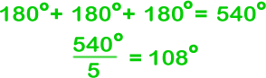
So the interior angles of a regular pentagon are each 108 degrees.
Can you figure out the hexagon?
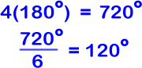
How about a 100-gon? (That's a regular polygon with 100 sides.) There would be 98 triangles...
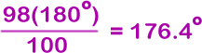
So, in general, the measure of an interior angle of a regular n-gon is
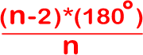

METHOD 2:
This method will be very similar to that of the first method. Except that we will draw our triangles using a point drawn inside the polygon.
 |  |  |  | 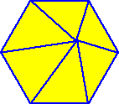
4 sides, 4 triangles |  | 5 sides, 5 triangles |  | 6 sides, 6 triangles
Notice that not all of the angles of the triangles are involved with the interior angles of the polygons. We'll need to figure out how to deal with that.
Starting with the square:
4 triangles...
At this point in method 1, we had 360... So we are off by 360. But we haven't dealt with the fact that those middle angles are not involved with the interior angles of the square. It turns out that the sum of the angles around that middle point is 360!
So
and 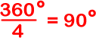
Let's try the pentagon...
5 triangles...
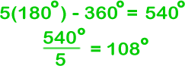
Can you figure out the hexagon?

In general, the measure of an interior angle of a regular n-gon is


