
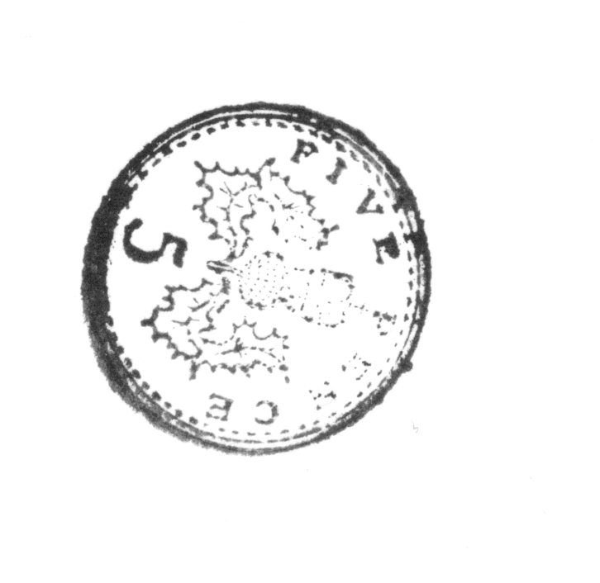

A lollipop costs 5p
A chocolate bar costs 10p

HOW MUCH WILL IT COST TO BUY?

5 CHOCOLATE BARS AND 3 LOLLIPOPS?

10 CHOCOLATE BARS AND 6 LOLLIPOPS?

3 CHOCOLATE BARS AND 10 LOLLIPOPS?

1 CHOCOLATE BAR AND 1 LOLLIPOP?

12 CHOCOLATE BARS AND 12 LOLLIPOPS?

I have 60p to spend, how many chocolate bars can I buy?

I have 20p to spend, how many lollipops can I buy?

I have 70p to spend, I need to buy 6 lollipops, how many chocolate bars can I buy with the change?

I have £1 and I need to get 6 chocolate bars and 6 lollipops, do I have enough money?

I have 45p to spend, how many lollipops can I buy?

I have 75p to spend, how many chocolate bars can I buy and will I have any change?

I have 15p to spend; do I have enough money for a chocolate bar and a lollipop?

