Name _____________________________ |  |  | Date ___________________
Improper Fractions
(Answer ID # 0810967)
Circle the correct improper fraction for the parts that are shaded.
  1. | 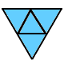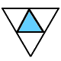
      4
      10
      4
      20
      20
      4
      13
      4
  2. | 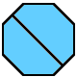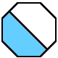
      2
      4
      2
      5
      5
      2
      2
      1
  3. | 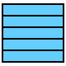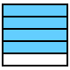
      5
      4
      5
      9
      5
      4
      9
      5
  4. | 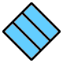
      3
      14
      14
      3
      8
      3
      3
      13
  5. | 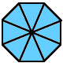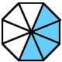
      28
      8
      40
      8
      8
      32
      8
      40
  6. | 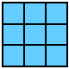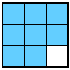
      9
      9
      17
      9
      9
      17
      15
      9
  7. | 
      19
      6
      13
      6
      6
      6
      6
      19
  8. | 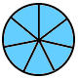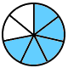
      19
      7
      7
      33
      7
      33
      7
      19
  9. | 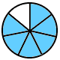
      10
      7
      7
      13
      13
      7
      24
      7
  10. | 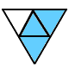
      4
      7
      15
      4
      23
      4
      7
      4

