GCSE Mathematics Practice : Answers

1. 3.27 × 10⁴

2.
a) 10 ⁶⁰⁰ ÷ 10 ³⁰³ = 10 ⁶⁰⁰⁻³⁰³ = 1×10 ²⁹⁷
b) 40×10 ³⁰³ = 4×10 ³⁰⁴

3. 453
×__73
1359
31710
33069

4. 1 man takes 6×8 = 48 days
4 men take 48÷4 = 12 days

5. 1 costs 3.48 ÷ 12
20 costs 3.48 ÷ 12×20 = £5.80

6. i) 800 ÷ 20
ii) 40

7. a) 6 + 3 + 1 = 10
128/"10" = 12.8
6 × 12.8 = 76.8 = £76.80
b) "76.8"/3 × 2 = £51.20

8. 750 is 85%
1% = 750 ÷ 85
100% = 750 × 85 ÷ 100 = £882.35

9. a) 3 × 2 × 0.5 = 3
- "3" × 25.85 = 77.55
- 0.125 × 1000 = 125
- "125" × 7.92 = 990
- "990" × 50 (= 49500)
"49500" ÷ 8.85 (= 5593.220...) = 5593

10. 2c - 3 + 2c + 3 + 4c - 5 = 31
8c - 5 = 31
8c = 36; c = 4.5

11. a) and b)
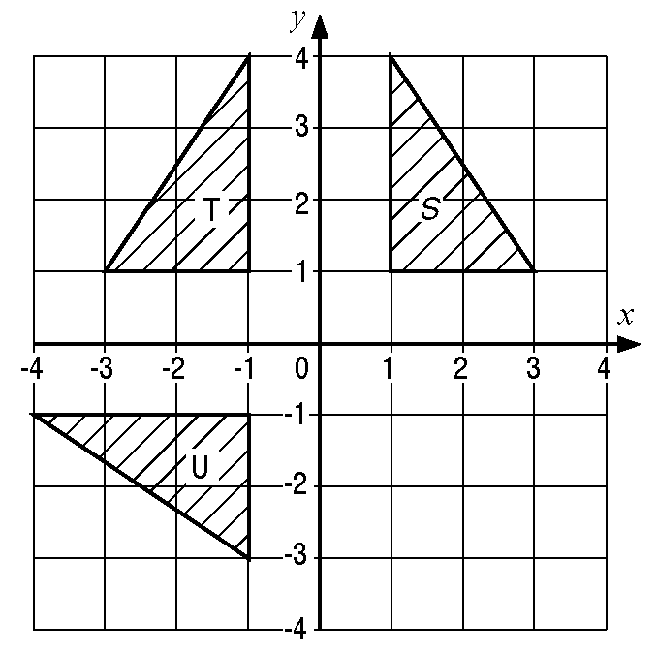
c) Reflection in the line y = -x

12. a) 2 × π × 6 or π × 12 = 37.7 cm
b) 12 × 130/100;
12 + 12 × 30/100 = 15.6 cm

13. a) i) 5.5 cm
ii) 4.5 cm
b) 0.2 km

14. a) -7, -4, 2, 5
b) pts plotted, line drawn
c) y = 3.5 → x = 1.5
x = -1.5→ y = -5.5

15. i) 3p = 29 - 5
3p = 24, p = 8
ii) 5q - 15 = 25; q = 8
iii) 8r = 12; r = 1.5

16. a) y = 3k -1
b) 3k - 1 = 14
3k = 14 + 1 = 15 so k = 5

17. i) 5x
ii) h⁵
iii) 6 mn
iv) 7x - 9

18. a) 88 m
b) AB constant speed
BC gradually slowing down
CD stationary.

19. a) 31, 43
b) add multiples of 2 in order to the
previous number

20. 3n + 2

21. 35/(3 + 4) (= 5)
3 × 5 = 15 OR 3/7×35 = 15

22. a) i) 4x³y²
ii) 16p⁴q⁶
b) i) 3a²b²(3b + 5a)
ii) (x + 12)(x - 5)
c)
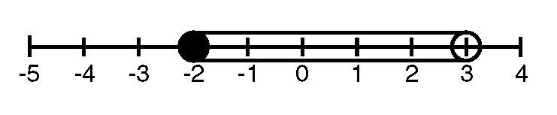

23. 2.5³ - 2.5 = 13.125
2.6³ - 2.6 = 14.976
2.7³ - 2.7 = 16.983
so x = 2.6

24. a) Mid point Total
162.5 1137.5
167.5 1005
172.5 345
177.5 1775
182.5 912.5
Total 5175
Mean = 5175 ÷ 30 = 172.5 cm
b) 7, 13, 15, 25, 30
c) Median = 175
Interquartile range = 17

25. a) Draw 3 more hexagons
b) 18, 22, 26, 30 in a table
c) 4 × 15 + 2 = 62

26. -2, -1, 0, 1, 2

27. 3x + 2y = 11
2x - 2y = 14
Adding gives
5x = 25 so x = 5
Substituting gives
15 + 2y = 11
so 2y = -4
therefore y = -2
28. circle around: r(r + 4h), ,

29. a) DC/8.2 = tan 37º
DC = 8.2 × tan 37º = 6.179...
b) sin DAB = 8.2/17.9 = 0.4581...
so DAB = 27.26... º = 27.3º

30. a) i) graph of x + y = 4 or y = -x + 4
ii) graph of y = x + 2
b) x = 1, y = 3

31. √(15² + 12²) = 19.2 cm

32. a) 360 - (120 + 85 + 93)
360 -298 = 62
b) 360 ÷ 6 = 60
c) 90 + 45,
180 - 45 or 3 × 45 or
2 × 67.5 = 135

33. a) i) 5 cm
ii) "5" × 20 = 100 km
b) i) 060º
ii) 180º + "60º" = 240º
- plane plotted 4 cm from mast bearing
of 220º

34. Area of base × 12 = 84
½ × 4 × h = 7
h = 3.5

35. (13$´$14) + 6 = 188
188$¸$2.2 = 85 kg

36. i) 1000/(2.54 × 3 × 12) = 10.9(36..) yds
ii) 100/"10.9" = 9.1743... = 9.1 - 9.2 m
37. 1 - (0.31 + 0.28 + 0.24) = 0.17

38. (21 - 16)/32 = 5/32

39. H1, H2, H3, H4, H5, H6
T1, T2, T3, T4, T5, T6

40. 1 - 1/12 = 11/12
accept 4/12 + 2/12 + 3/12 + 2/12 = 11/12

41. a) 1/36, 2/36, 3/36 etc
b) i) 10/36
ii) 10/36
iii) 15/36

42. a) graph
b) negative

43. a) 140º, 16º, 56º, 94º, 54º or answers that round to.
b) Sectors drawn, ft from (a). If it fits overlay than (a) & (b) gets 3 + 3 or 3 + 2 dep. on labels and non-contradicting table.
c) 289/1800 =7/45

44. a) = 15.5
b) cos angle = 4/16; angle = 75.5º

45. a) e.g. 2.23 m can be measured: π normally give to 2 d.p.
b) 2nd not accurate; not near enough to 7m; 1st too accurate: cannot be measured

46. a) 2 × 10 + 22 × 30 + 13 × 50 + 10 × 70 + 5 × 90 + 2 × 110 + 1 × 130 = 20 + 660 + 650 + 700 + 450 + 220 + 130 = 2830 (= 51.4545...) = 51.5
b) 40 < L ≤ 60

