

MIDLAND EXAMINING GROUP 1662/1

General Certificate of Secondary Education

MATHEMATICS SYLLABUS A
PAPER 1 (Foundation Tier)
SPECIMEN PAPER
Candidates answer on the question paper.
Additional materials:
Electronic calculator
Geometrical instruments
Tracing paper (optional)
TIME 1 hour 30 minutes
INSTRUCTIONS TO CANDIDATES
Write your name, Centre number and candidate number in the spaces at the top of this page.
Answer all questions.
Write your answers in the spaces provided on the question paper.
Show all your working. Marks may be given for working which shows that you know how to solve the problem, even if you get the answer wrong.
INFORMATION FOR CANDIDATES
The number of marks is given in brackets [ ] at the end of each question or part question.
You are expected to use an electronic calculator for this paper.
Unless otherwise instructed in the question, take to be 3.142 or use the button on your calculator.

Formulae Sheet: Foundation Tier
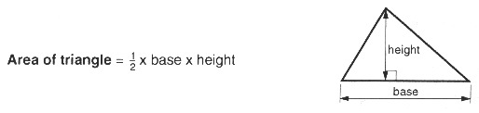
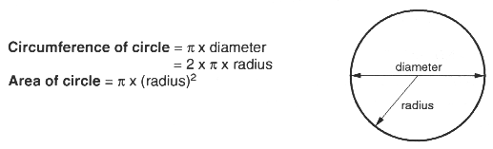
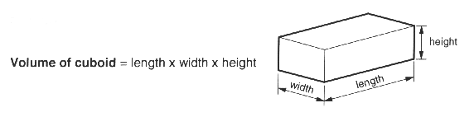

1 (a) Write in figures the number three thousand one hundred and seven.
Answer (a) ______________________________________ [1]
(b) Subtract six hundred and ninety from three thousand one hundred and seven.
......................................................................................................................................................
......................................................................................................................................................
Answer (b) ______________________________________ [1]

2 Fill in the blanks in this sequence of odd numbers.
___, ___, 13, 15, 17, ___, ___ [2]

3 Use your calculator to find 75, correct to the nearest whole number.
......................................................................................................................................................
Answer __________________________________________ [2]

4 (a) Is 57 a multiple of 7?
Explain your answer.
Answer (a) __________________________________________
___________________________________________________________________________
_______________________________________________________________________ [2]
(b) Write 438 days in weeks, to the nearest week.
......................................................................................................................................................
......................................................................................................................................................
Answer (b) ________________________________ weeks [3]

5 The scores (out of 25) achieved by 20 people in a quiz competition were:
16 19 17 6 11 8 14 21 23 9
12 7 14 18 22 13 24 4 22 12
Complete the frequency table below.
Score Tally marks Frequency

0 - 5

6 - 10

11 - 15

16 - 20

21 - 25

[3]

6
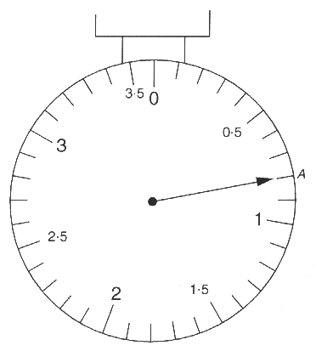
These kitchen scales weigh in kilograms.
(a) Write down the weight when the pointer is at A.
Answer (a) ______________________________________ [2]
(b) On the diagram draw another pointer B to indicate a weight of 2.85 kg. [2]

7 'The probability that Nottingham Forest will win the F.A. Cup is 1.2.'
'The probability that Birmingham City will win the F.A. Cup is -0.5.'
Explain why the value of the probability in each of these statements is not possible.
Answer ______________________________________________
___________________________________________________________________________
___________________________________________________________________________
_______________________________________________________________________ [3]

8 (a) Draw a square of side 5 centimetres.
[2]
(b) Draw a rectangle that is not a square.
[2]

9
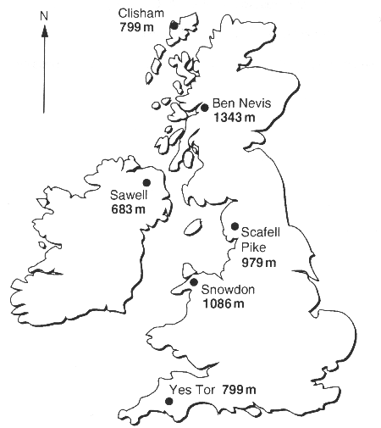
The map shows the positions and heights of six mountains.
(a) Write the names of the six mountains in order of height.
Put the highest mountain first.
Answer (a) ______________________________________
____________________________________________________________
____________________________________________________________
____________________________________________________________
____________________________________________________________
____________________________________________________________ [2]
(b) Helvellyn is added to the list of mountains in part (a).
It is fourth in the new list.
What can be said about the height of Helvellyn?
Answer (b) __________________________________________
____________________________________________________________ [2]

10 The bar chart below shows the shoe sizes of a group of 16 year old boys.
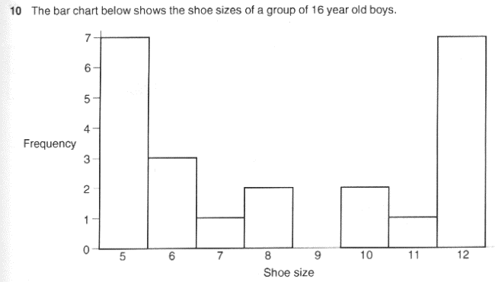
(a) How many boys are there in the group?
Answer (a) ______________________________________ [2]
(b) Comment on the shape of the bar chart, saying whether or not this is the shape you would expect.
Answer (b) __________________________________________
______________________________________________________________
______________________________________________________________[2]

11 A square piece of paper of side six centimetres is folded in half and then folded in half again as shown in the diagram. A triangle is cut out through all four sections of the folded paper.
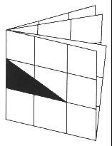
NOT TO SCALE
(a) The piece of paper is now opened out as shown below. Mark on it the two pieces that have been cut out [2]
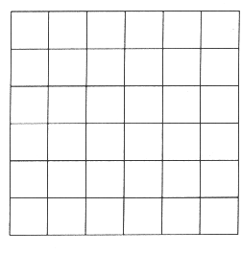
(b) On your diagram draw any lines of symmetry. [2]
(c) Look at this statement:
"The two pieces that have been cut out are ................................ triangles."
Which of the following words could be put in the blank space to make the statement correct?
scalene isosceles equilateral right-angled
Answer (c) ______________________________________ [1]

12
Row 1 1 Sum = 1

Row 2 3 5 Sum = 8 = 2³

Row 3 7 9 11 Sum = 27 = 3³

(a) Write down the numbers and the Sum which continue the pattern in Row 4.
......................................................................................................................................................
......................................................................................................................................................
Answer (a) ______________________________________ [2]
(b) Which Row will have a Sum = 1000?
......................................................................................................................................................
......................................................................................................................................................
Answer (b) ______________________________________ [1]
(c) What is the Sum of Row 20?
......................................................................................................................................................
......................................................................................................................................................
Answer (c) ______________________________________ [2]
(d) The first number in a row is x.
What is the second number in this row? Give your answer in terms of x.
......................................................................................................................................................
......................................................................................................................................................
Answer (d) ______________________________________ [1]

13
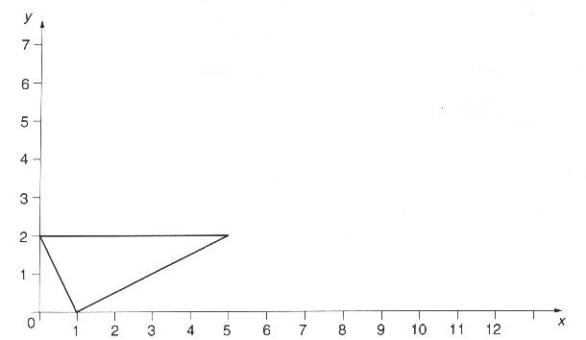
(a) Write down the coordinates of the three vertices of the triangle.
Answer (a) ( , )
( , )
( , ) [3]
(b) Draw at least six more identical triangles on the diagram above, to form a tessellation.[3]

14 Solve the equations
(a) x + 7 = 18,
......................................................................................................................................................
Answer (a) x = _______________________ [1]
(b) 5y = 45,
......................................................................................................................................................
Answer (b) y = __________________________________ [2]
(c) 3z + 2 = 14.
......................................................................................................................................................
Answer (c) z = _______________________ [2]

15
HOUSEHOLDS WITH TELEVISION LICENCES
1966 1971 1976 1981 1986

Black & white 53% 62% 36% 18% 12%

Colour 0% 10% 49% 69% 81%

To watch TV, you are required to have either a black & white licence or a colour licence.
(a) What percentage of households had a TV licence in 1976?
......................................................................................................................................................
Answer (a) ____________________________________ % [2]
(b) Comment on how the percentage of licences for colour television compares with the percentage of licences for black & white television over the years 1966 to 1986.
Answer (b) __________________________________________
___________________________________________________________________________
_______________________________________________________________________ [2]
(c) Estimate the year in which the percentage of colour TV licences overtook the percentage of black & white licences.
Answer (c) ______________________________________ [2]
(d) In 1991, 97% of households had a TV licence.
What fraction of households did not have a TV licence?
Answer (d) ______________________________________ [2]

16 At 1 p.m. the temperature in Birmingham was 5°C.
According to the weather forecast, the temperature at midnight was expected to be -4°C.
(a) By how many degrees was the temperature expected to fall?
......................................................................................................................................................
......................................................................................................................................................
Answer (a) ______________________________________ [1]
(b) In fact the temperature at midnight was 2°C lower than expected.
What was the temperature at midnight?
......................................................................................................................................................
......................................................................................................................................................
Answer (b) ______________________________________ [1]

17
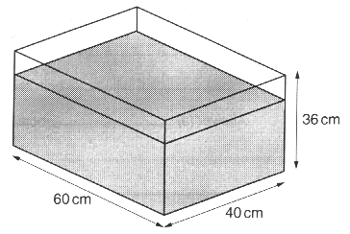
NOT TO SCALE
A rectangular tank has length 60 cm, width 40 cm and height 36 cm.
It is placed on a horizontal table.
Water is poured into the tank until it is three quarters full.
(a) Calculate the depth of the water in the tank.
......................................................................................................................................................
......................................................................................................................................................
Answer (a) ___________________________________ cm [2]
(b) Calculate how many litres of water there are in the tank.
......................................................................................................................................................
......................................................................................................................................................
......................................................................................................................................................
Answer (b) _______________________________ litres [2]

18 (a) List the following numbers in order, starting with the smallest:
-0.3, 0.6, 0.59, -0.34.
......................................................................................................................................................
......................................................................................................................................................
Answer (a) ____________________________________ [2]
(b) Work out 2 3/8 + 1 1/2.
......................................................................................................................................................
......................................................................................................................................................
Answer (b) ______________________________________ [2]

19
(a) The fifteen members of a hockey squad were asked what size of boot they wore.
The replies were:
6, 3, 7, 8, 7, 6, 3, 5, 4, 6, 3, 7, 5, 4, 7.
For these sizes, find
(i) the mode,
......................................................................................................................................................
......................................................................................................................................................
Answer (a) (i) __________________________________ [1]
(ii) the median,
......................................................................................................................................................
......................................................................................................................................................
Answer (a) (ii) _________________________________ [2]
(iii) the range.
......................................................................................................................................................
......................................................................................................................................................
Answer (a) (iii) ________________________________ [1]
(b) The fifteen members of a rugby team were asked what size of boot they wore.
For their replies, the mode was 8, the median was 7 and the range was 3.
Comment on how the boot sizes for the rugby team differ from those of the hockey squad in part (a).
Answer (b) ____________________
___________________________________________________________________________
_______________________________________________________________________ [2]

20
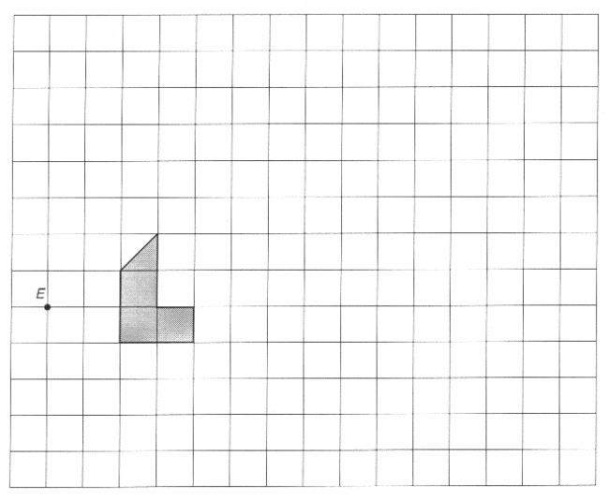
Enlarge the shaded figure, using scale factor 3 and centre of enlargement E.[2]

21 Ann and Bill share £400 in the ratio 5 : 3.
(a) How much does each of them receive?
......................................................................................................................................................
......................................................................................................................................................
......................................................................................................................................................
Answer (a) Ann receives £ _______________________ [1]
Bill receives £ _________________________________ [3]
(b) Bill gives £45 of his share to a charity.
What percentage is this of his share?
......................................................................................................................................................
......................................................................................................................................................
......................................................................................................................................................
Answer (b) ____________________________________ % [2]

22 The 500 children in a school each bought one ticket for the school's prize draw.
The 500 tickets, numbered from 1 to 500, will be put in a barrel and the winning ticket drawn.
(a) Ambrose has the ticket numbered 350.
What is the probability that he will win the prize?
......................................................................................................................................................
......................................................................................................................................................
Answer (a) ______________________________________ [1]
(b) What is the probability that the winning ticket number will be greater than 350?
......................................................................................................................................................
......................................................................................................................................................
Answer (b) ______________________________________ [2]
(c) Melanie says 'Either a boy or a girl must win, so the probability that a girl will win is ½'.
Explain why she might be wrong.
Answer (c) __________________________________________
___________________________________________________________________________
_______________________________________________________________________ [1]

23 The length of a rectangle is 2 cm more than its width.
(a) Calculate the area of the rectangle
(i) when the width is 4 cm,
......................................................................................................................................................
......................................................................................................................................................
Answer (a) (i) ______________________ [1]
(ii) when the width is 5 cm.
......................................................................................................................................................
......................................................................................................................................................
Answer (a) (ii) _________________________________ [1]
(b) Using a trial and improvement method, find the width of the rectangle given that its area is 32 cm².
Give your answer in centimetres correct to one decimal place. (You must show all your trials.)
___________________________________________________________________________
___________________________________________________________________________
___________________________________________________________________________
___________________________________________________________________________
___________________________________________________________________________
Answer (b) ___________________________________ cm [3]

24 Ten boys of different ages were set the same General Knowledge test.
The results are shown in the table below.
Boy A B C D E F G H I J

Age (months) 131 142 152 153 158 163 166 170 172 173

Score 18 23 27 32 24 28 26 35 32 25

(a) The mean of the ages of the boys is 158 months.
Calculate the mean of their scores.
......................................................................................................................................................
......................................................................................................................................................
......................................................................................................................................................
Answer (a) ______________________________________ [3]
(b) The results in the table have been plotted on the scatter graph below.
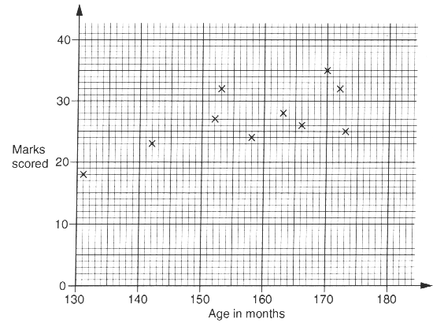
Does the scatter graph show the sort of result you would expect? Explain your answer.
Answer (b) __________________________________________
___________________________________________________________________________
_______________________________________________________________________ [2]

