
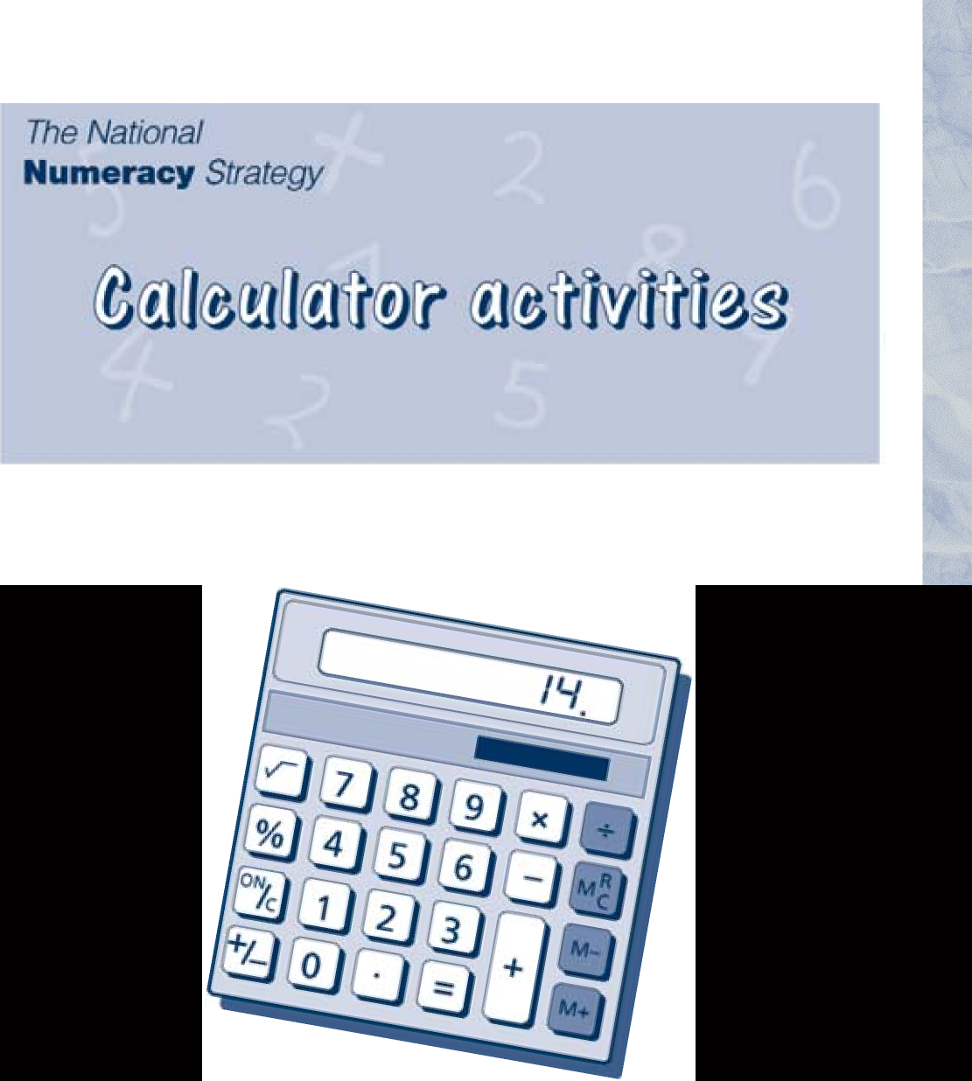

The activities in this booklet make use of a calculator as a teaching and learning aid. They are intended to help children in Key Stage 2 to understand and practise the mathematical ideas and skills which the activities require.
The activities may be copied freely by schools in England taking part in the National Numeracy Strategy.

The National Numeracy Strategy: Calculator activities 1

Words

Set 1
Forty-three Eight-six Ninety Eighteen Thirty-nine Fifty-seven
Check number: 333

Set 2
One hundred and fifty-six
Two hundred and seven Seven hundred and five Three hundred and twelve
Six thousand, one hundred and forty One thousand and eighty
Check number: 8600
Use only these numbers and the ~ sign.
47 17
Complete these.
- ..
- ..

- ..
- ..
- ..

The National Numeracy Strategy: Calculator activities
2

Each person in the group should have a calculator.
One person reads out the numbers. The others enter them into their calculator, pressing the ~ key after each one.
Did everyone get the check number?

Triples

39 23 |  | 38
~ ... ~ | 109
~ ... ~ | 78
~ ... ~ | 124
~ ... ~ | 103
~ ... ~ | 102

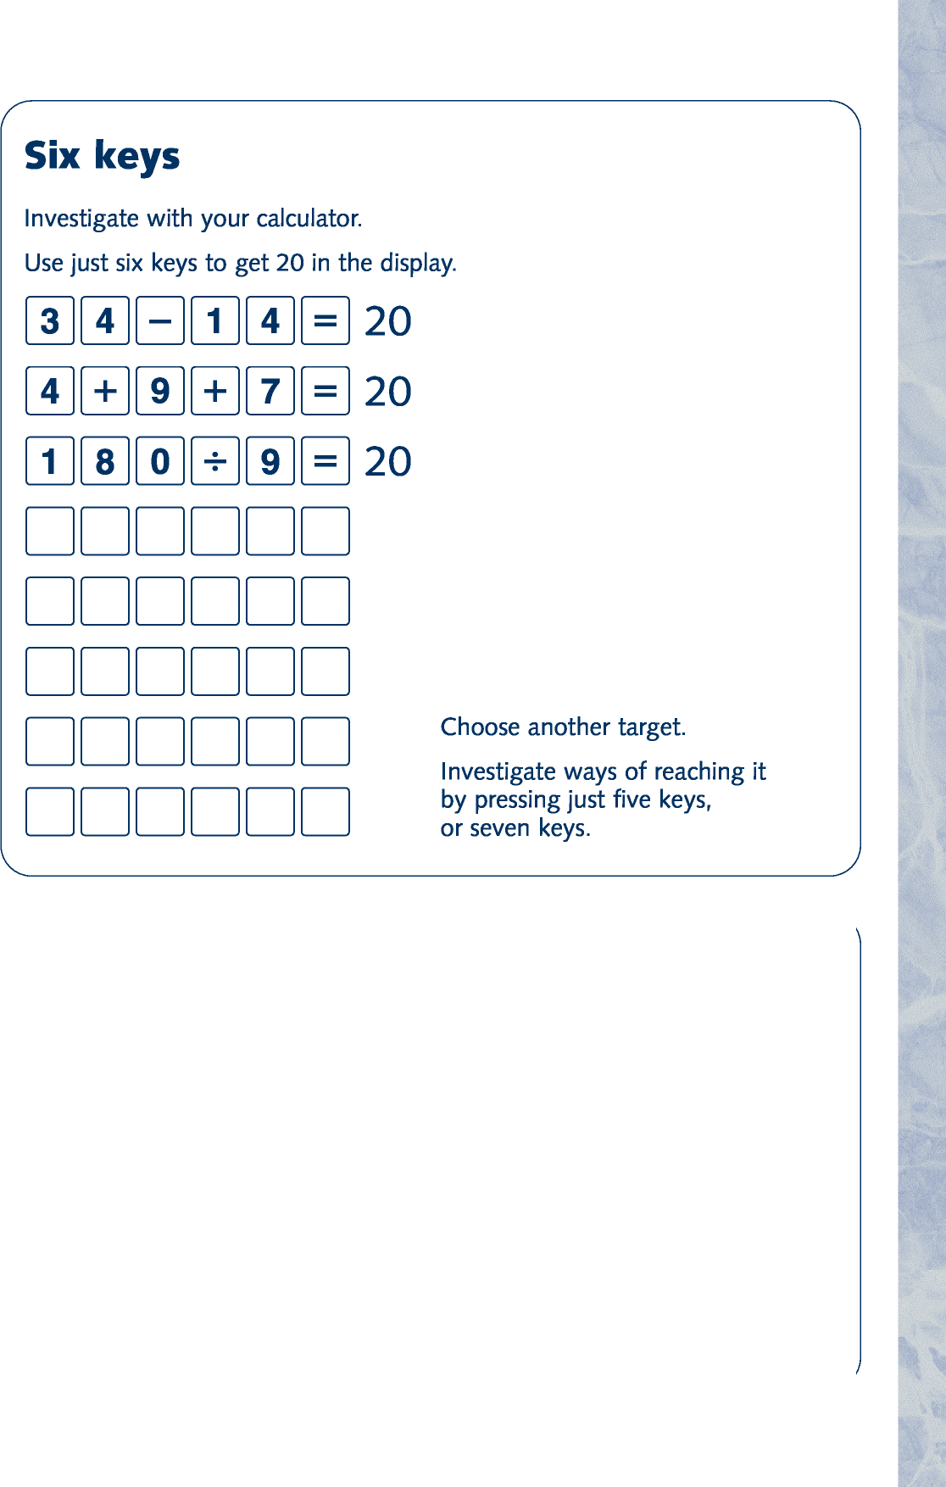The National Numeracy Strategy: Calculator activities
3
Boxes
Fill in the boxes. Use only these numbers: 149, 217, 269, 282, 306.
a. |  | ~ |  | ~ | 68 f. |  | ~ |  | ~ 431
b. |  | ~ |  | ~ | 55 g. |  | ~ |  | ~ 486
c. |  | ~ |  | ~ | 588 h. |  | ~ |  | ~ 37
d. |  | ~ |  | ~ | 157 i. |  | ~ |  | ~ 523
e. |  | ~ |  | ~ | 65 j. |  | ~ |  | ~ 418

Calculator Nim

1

2

3

4

5

6

7

8

9

Bull’s eye

Choose a starting number (for example, 17) and a target number (for example, 100).
Find which number to multiply the starting number by to give the target number, correct to an agreed degree of accuracy.
The National Numeracy Strategy: Calculator activities
4

This is a game for two players with one calculator between them. You may use only these keys.

Take turns to add a single-digit number to what is already in the calculator. The winner is the player who makes the display show 30. If you go over 30 you lose.
Variations
Choose a different target number.
Play the game using subtraction. In this case you must start by entering a number such as 60, and set a target of a smaller number, such as 25.
Make the target 200 or more, and add two-digit numbers.
Play the game using multiplication. In this case start by putting 1 in the display, and set a target such as 1000.

1

0

5
The National Numeracy Strategy: Calculator activities
5

One, zero, five
Use only these keys on your calculator.

Make each of these numbers. Press as few keys as possible.
16, 37, 88, 638
Record how you did it.

Make 1000
Choose any four numbers from the grid and add them up.
275 | 382 | 81 | 174
206 | 117 | 414 | 262
483 | 173 | 239 | 138
331 | 230 | 325 | 170
Find as many ways as possible of making 1000.

Only one number

Down on the farm
There are some rabbits and chickens in a field.
Together they have 35 heads and 94 feet.

How many rabbits? How many chickens?
6

17 can be changed to 1 by using only the number 4 key, together with any of the operation keys. For example,
17 ~ | 4 ~ | 68
~ | 4 ~ | 64
~ | 4 ~ | 16
~ | 4 ~ | 4
~ | 4 ~ | 1
Find other numbers that can be changed to 1 using only the 4 key and any operation.
Try other number keys, e.g. 5 or 3.
17 ~ | 5 ~ | 12 | 17 ~ | 3 ~ | 51
~ | 5 ~ | 7 | ~ | 33 ~ | 18
~ | 5 ~ | 2 | ~ | 3 ~ | 6
~ | 5 ~ | 10 | ~ | 3 ~ | 3
~ | 5 ~ | 5 | ~ | 3 ~ | 1
~ | 5 ~ | 1
What did you discover?

The National Numeracy Strategy: Calculator activities

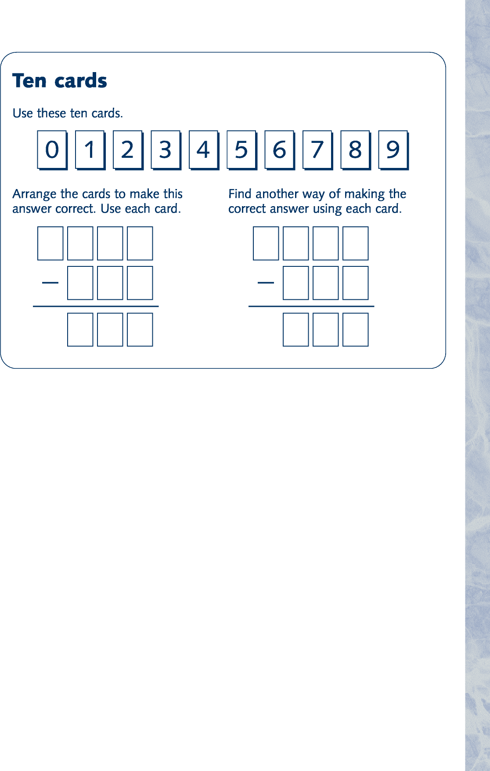
Whole numbers

~

7

8

9

5

6

~

6

4

9

~

7

4

7

0

7

~

9
The National Numeracy Strategy: Calculator activities
7

Some of the digits in these divisions are missing.
The answer to each division is a whole number. Find the missing digits.



Only these keys

Largest and smallest
You may use each of these keys only once.
What is the largest number you can make? What is the smallest number you can make?
Try with five other digits.
Try using 1, 2, 3, 4, 5, 6, or 1, 2, 3, 4, 5, 6, 7.
Can you find a rule for making the biggest product?

1

2

3

4

5

3

5

~

4

7

~
The National Numeracy Strategy: Calculator activities
8

You may press only these keys, but as often as you like.

Find which of the numbers from 1 to 20 you can get. What is the largest number you cannot get?
You may press only these keys, but as often as you like.
Find which of the numbers from 1 to 30 you can get. What is the largest number you cannot get?
Try some other pairs of numbers.
Keep a record of the largest number you cannot make. Can you find a rule?

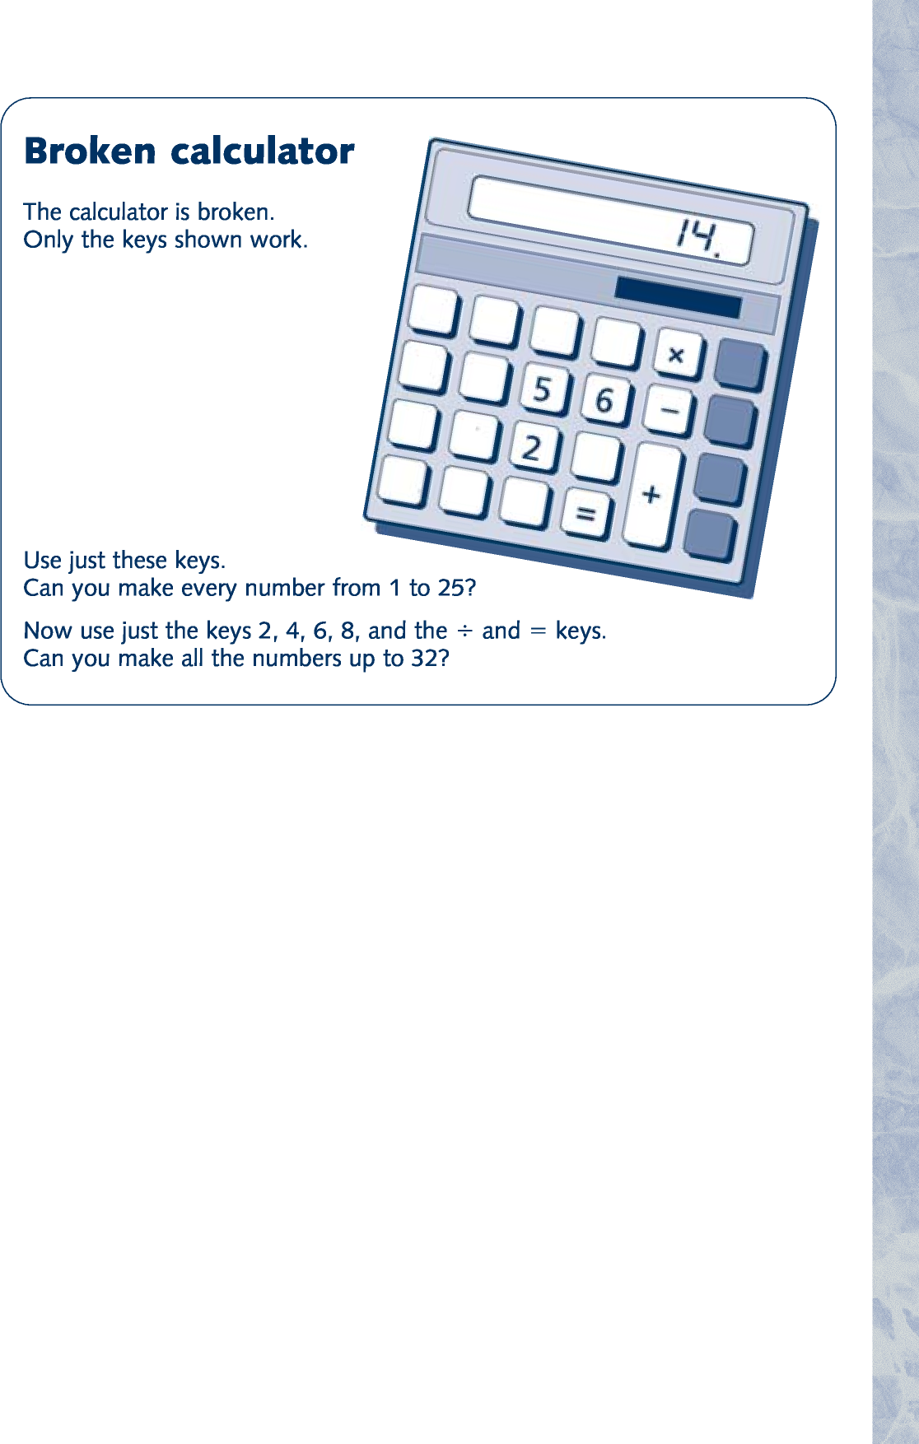
Elevenses
The National Numeracy Strategy: Calculator activities
9

Choose a two-digit number 37
Reverse it 73
Add them together 110 This is divisible by 11.

Try a four-digit number… 1653
Reverse it 3561
Add them together 5214 Is this divisible by 11?

Try other two- or four-digit numbers. Does it always work?
What about three-digit numbers? Can you find a rule?
Crossover

Missing digits
Each box represents a missing digit. Can you find out what it is?
a. 1~2 ~ 14~ ~ 24~40
b. 93 ~ 8~ ~ 7~~8
c. 83~ ~ ~9 ~ 41013
d. ~~6 ~ 84~ ~ 232668
e. 3~~ ~ ~7 ~ 14171
The National Numeracy Strategy: Calculator activities
10

This is a game for two players.
Each player has a starting number.
One player adds to and the other subtracts from their total.
The totals move towards each other.
The aim is to avoid meeting or crossing over the other player’s total.
The first to meet or cross over loses. Example
Player A Player B
Start 13 Start 34
- 6 19 ~ 3 31
- 10 29 ~ 1 30
- 0.5 29.5 ~ 0.1 29.9
- 0.25 29.75 ~ 0.14 29.76
and so on.

Invaders
The National Numeracy Strategy: Calculator activities
11

Put a six-digit number in the display.
You must change each digit to zero in as few turns as possible.
On each turn you can use only one number key, the zero key as often as you like, and the ~ key.
Example
Start number Key presses |  | Display
123476 ~ | 4 | 123480
~ 2 | 0 | 123500
~ 5 0 | 0 | 124000
~ 6 0 0 | 0 | 130000
~ 7 0 0 0 | 0 | 200000
~ 8 0 0 0 0 | 0 | 1000000

Variation
This time use decimals: for example, 451.326.
Use subtraction.
Shoot down the digits to zero in the order 1, 2, 3, 4, 5, 6.

Missing operations

Each box represents a missing operation ( ~, ~, ~ or ~ ). Can you find out what it is?
a. (37 ~ 21) ~ 223 ~ 1000
b. (756 ~ 18) ~ 29 ~ 1218
c. 27 ~ (36 ~ 18) ~ 675
d. 31 ~ (87 ~ 19) ~ 2108

Products
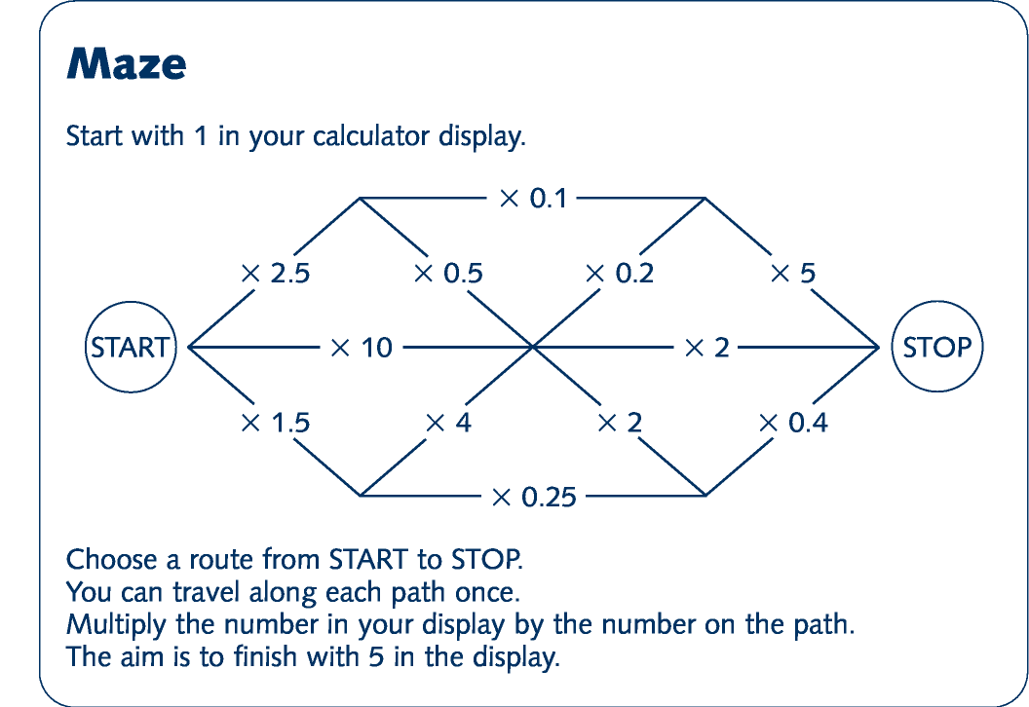
The National Numeracy Strategy: Calculator activities
12

A game for two players or teams, each with their own coloured pen. Take turns to choose two of these numbers.
7 16 27 31 46 56 67 71 Multiply them together. If you can, ring the answer on the grid.
506 | 1426 | 217 | 837 | 1136 | 3266
4757 | 1809 | 1242 | 3082 | 341 | 112
77 | 496 | 3752 | 432 | 176 | 2201
1917 | 736 | 737 | 189 | 2576 | 1072
616 | 322 | 896 | 781 | 3976 | 497
469 | 1512 | 1736 | 2077 | 392 | 297
The winner is the first team with four rings in a line in any direction.
Notes
The National Numeracy Strategy: Calculator activities 13
Notes
The National Numeracy Strategy: Calculator activities 14
Notes
The National Numeracy Strategy: Calculator activities 15

Notes

Department for Education and Employment Sanctuary Buildings
Great Smith Street London SW1P 3BT
© Crown copyright 1999
Extracts from this document may be reproduced for non-commercial educational or training purposes on condition that the source is acknowledged.
ISBN 0 19 312291 X Printed in Great Britain

