Sin, Cos and Tan

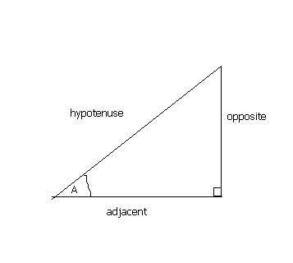
In any right angled triangle, for any angle:
The sine of the angle = the length of the opposite side
the length of the hypotenuse
The cosine of the angle = the length of the adjacent side
the length of the hypotenuse
The tangent of the angle = the length of the opposite side
the length of the adjacent side
The hypotenuse of a right angled triangle is the longest side, which is the one opposite the right angle. The adjacent side is the side which is between the angle in question and the right angle. The opposite side is opposite the angle in question.
sin = o/h cos = a/h tan = o/a
Often remembered by: soh cah toa

Example:
Find the length of side x in the diagram below:

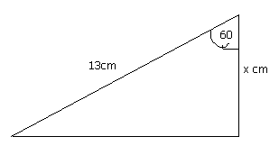
The angle is 60 degrees. We are given the hypotenuse and need to find the adjacent side. This formula which connects these three is:
cos(angle) = adjacent / hypotenuse
therefore, cos60 = x / 13
therefore, x = 13 × cos60 = 6.5
therefore the length of side x is 6.5cm.

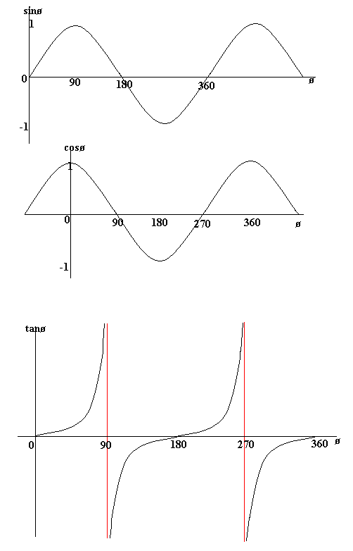
The graphs of sin, cos and tan
The following graphs show the value of sinø, cosø and tanø against ø (ø represents an angle). From the sin graph we can see that sinø = 0 when ø = 0 degrees, 180 degrees and 360 degrees.

