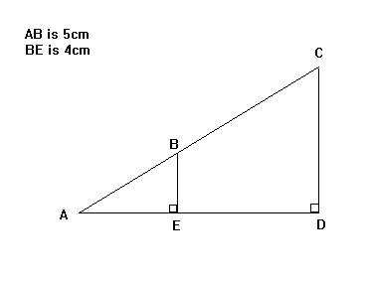
AB : AC = 1 : 3
(i) Work out the length of CD.
(ii) Work out the length of BC.

1. | 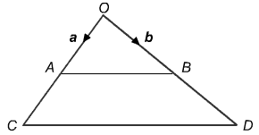  In the diagram A and B are the midpoints of OC and OD respectively.  a) Write down in terms of a.  (1 mark)  b) (i) Write down in terms of a.  (1 mark)  (ii) Use a vector method to prove that CD is parallel to AB.  (3 marks)  (iii) What other conclusions can you make about AB and CD?  (1 mark)  E is the midpoint of CD.  c) Use a vector method to prove that OAEB is a parallelogram.  (2 marks)
 | (Marks available: 8)
 | Source: OCR 2000 |  | Answer

2. | 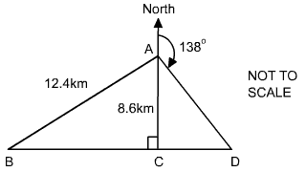  The diagram shows the positions of points A, B, C and D.  A is due North of C. The straight line BCD is perpendicular to AC.  A is 12.4 kilometres from B and 8.5 kilometres from C.  a) Calculate the distance BC.  (3 marks)  b) The bearing of D from A is 138°.  Calculate the distance DC.  (3 marks)
 | (Marks available: 6)
 | Source: OCR 2000 |  | Answer

3. | 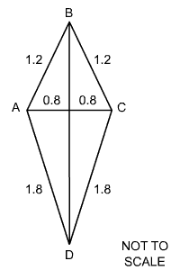  a) The diagram shows a kite ABCD with measurements in metres.  BD bisects AC at right angles.  Calculate the size of angle ABC.  (4 marks)  b)  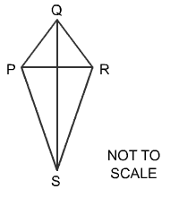  PQRS is similar to ABCD.  PR is of length 1m.  Calculate the length of the side PS.  (2 marks)
 | (Marks available: 6)
 | Source: OCR 2000 |  | Answer

4. | O is the centre of a circle through A, B, C and D.  Angle DOC is 110° and angle OCB is 65°.  a)  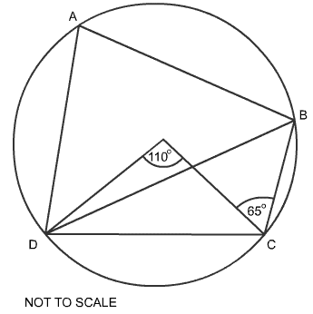  (i) Find angle DBC.  (1 mark)  (ii) Fnd angle DCO.  (1 mark)  (iii) Find angle DAB.  (1 mark)  b)  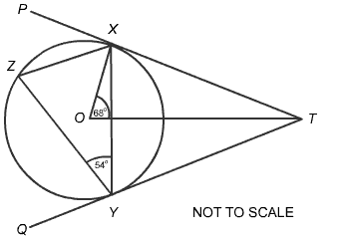  (i) Find angle PXZ.  (1 mark)  (ii) Find angle OTY.  (2 marks)
 | (Marks available: 6)

