The Trigonometric Functions
Let us return to the diagram of the right-angled triangle.
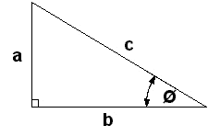
There are a number of relations between the sides a, b, and c and the angle φ. These are called the Trigonometric Functions.
There are three main Trigonometric Functions. These are called Sine, Cosine and Tangent.
The Sine of the angle φ is defined as the length of the opposite side (opposite to the angle φ) divided by the hypotenuse.
This is written as
Sin φ = a / c
The Cosine of the angle φ is defined as the length of the adjacent side (adjacent to the angle φ) divided by the hypotenuse.
This is written as
Cos φ = b / c
The Tangent of the angle φ is defined as the length of the opposite side (opposite to the angle φ) divided by the length of the adjacent side (adjacent to the angle φ).
This is written as
Tan φ = a / b
The table below shows some of the values of these functions for various angles.
Angle | Sin | Cos | Tan
0º | 0.000 | 1.000 | 0.000
30º | 0.500 | 0.866 | 0.577
45º | 0.707 | 0.707 | 1.000
60º | 0.866 | 0.500 | 1.732
90º | 1.000 | 0.000 | Infinite
Note the following:
Sin 0º = Cos 90º = 0
Sin 30º = Cos 60º = 0.500
Sin 45º = Cos 45º = 0.707 = 1 / (√2)
Sin 60º = Cos 30º = 0.866 = (√3) / 2
Sin 90º = Cos 0º = 1
Between 0º and 90º:
Sines increase from 0 to 1,
Cosines decrease from 1 to 0,
Tangents increase from 0 to infinity.
The values of the Trigonometric Functions (except for 0º, 30º, 45º, 60º, 90º) are not whole numbers, fractions or surds. They are transcendental.

The three Trigonometric Functions are related.
Sin φ / Cos φ = Tan φ
Sin²φ + Cos²φ = 1
This is a side note: The square of a Sine of an angle, say (Sin φ)² is more commonly written as Sin²φ. This form applies to all the Trigonometric Functions.
Prove that Sin φ / Cos φ = Tan φ
By using the definitions of the Trigonometric Functions
Sin φ / Cos φ = (a / c) / (b / c) = (a / c) × (c / b) = a / b = Tan φ
Prove that Sin²φ + Cos²φ = 1
By using the definitions of the Trigonometric Functions
Sin²φ + Cos²φ = (a / c)² + (b / c)² = (a² / c²) + (c² / b²) = (a² + b²) / c².
But a² + b² = c² (from Pythagoras' Theorem)
Therefore (a² + b²) / c² = c² / c² = 1.
Values for the Trigonometric Functions for a particular angle can be found in tables or on a calculator as with Logarithms. We will use them now in some examples.
Find the length of the sides a and c in the following right-angled triangle.
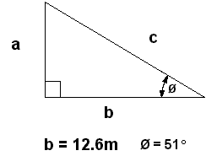
Using the definition of Tangents and rearranging we have
a = b × Tan φ = 12.6 × Tan 51º = 12.6 × 1.235
Using a calculator or tables we can find that Tan 51º = 1.235 (to three decimal places).
12.6 × 1.235 = 15.56m.
The value of c can be found by using Pythagoras' Theorem. Here we will use the definition of Cosines and rearrange. This gives
c = b / Cos φ = 12.6 / Cos 51º = 12.6 / 0.629 = 20.03m.
Find the angle, φ, in the following right-angled triangle.
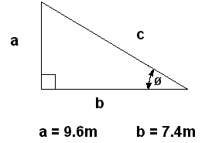
Using the definition of Tangents
Tan φ = a / b = 9.6 / 7.4 = 1.297.
Using tables or a calculator, φ = 52.37º.

The Sine and Cosine Rules
So far, we have been looking at right-angle triangles. In general, triangles can have any angles. Consider the triangle below.
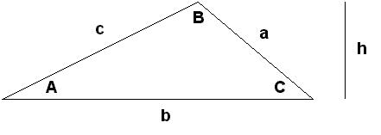
The triangle has three sides, a, b, and c. There are three angles, A, B, C (where angle A is opposite side a, etc). The height of the triangle is h.
The sum of the three angles is always 180º.
A + B + C = 180º
The area of this triangle is given by one of the following three formulae
Area = (a × b × Sin C) / 2 = (a × c × Sin B) / 2 = (b × c × Sin A) / 2
= b × h / 2
The relationship between the three sides of a general triangle is given by The Cosine Rule. There are three forms of this rule. All are equivalent.
a² = b² + c² - (2 × b × c × Cos A)
b² = a² + c² - (2 × a × c × Cos B)
c² = a² + b² - (2 × a × b × Cos C)
Show that Pythagoras' Theorem is a special case of the Cosine Rule.
In the first version of the Cosine Rule, if angle A is a right angle, Cos 90º = 0. The equation then reduces to Pythagoras' Theorem.
a² = b² + c² - (2 × b × c × Cos 90º) = b² + c² - 0 = b² + c²
The relationship between the sides and angles of a general triangle is given by The Sine Rule.
a / Sin A = b / Sin B = c / Sin C
Find the missing length and the missing angles in the following triangle.
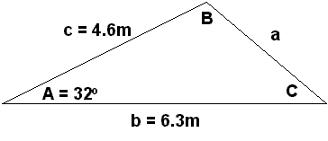
By the Cosine Rule,
a² = b² + c² - (2 × b × c × Cos A)
a² = 6.3² + 4.6² - (2 × 6.3 × 4.6 × Cos 32º)
a² = 39.69 + 21.16 - (2 × 6.3 × 4.6 × 0.848)
a² = 60.85 - 49.15 = 11.7
a = 3.42m
Now, from the Sine Rule,
a / Sin A = c / Sin C
This can be rearranged to
Sin C = (c × Sin A) / a
By putting in the various values we get
Sin C = (c × Sin A) / a = (4.6 × Sin 32º) / 3.42 = (4.6 × 0.530) / 3.42 = 0.713
Therefore
C = 45.5º
The final angle can be found from
A + B + C = 180º
Rearanging,
B = 180 - A - C = 180 - 32 - 45.5
B = 102.5º
Using the equations descibed in this essay, it is possible to find out everything about a triangle from just a few given bits of information. In the above example we have calculated that a = 3.42m, B = 102.5º, C = 45.5º.

