Sine and Cosine Formulae
Sine and Cosine Formulae
From the graph of sin, we see that:
sin x = sin (180 - x)
e.g. sin 130 = sin (180 - 130) = sin 50
Also:
cos x = -cos (180 - x)
The Sine Rule
This works in any triangle (it doesn't have to be right-angled!):
a = b = c
sinA sinB sinC
alternatively, sinA = sinB = sinC
a b c
NOTE: the triangle is labelled as follows:

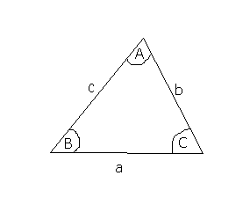
The Cosine Rule
c² = a² + b² - 2abcosC
can also be written as:
a² = b² + c² - 2bccosA
This also works in any triangle.

The area of a triangle
The area of any triangle is ½ absinC (using the above notation).
This formula is useful if you don't know the height of a triangle (since you need to know the height for ½ base × height).

