Can you work out the value of each of the fruit in this puzzle?

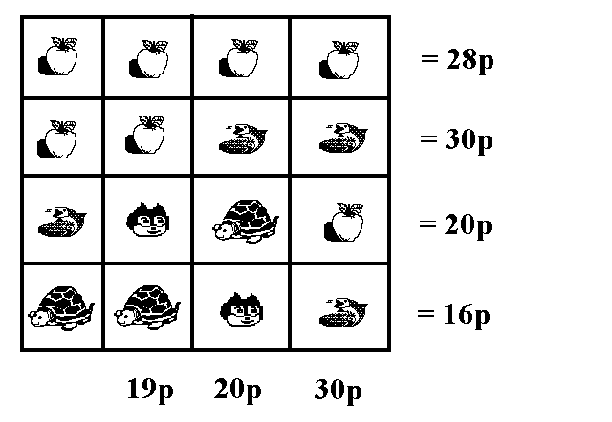

Can you work out the value of each of the fruit in this puzzle?

